1.
Draw a diagram of the OSI 7-layer model and label each layer with its correct name and a real-world example of a device or protocol that operates at that layer (e.g., Switch at Data Link, HTTP at Application).
REAL WORLD E.G. : 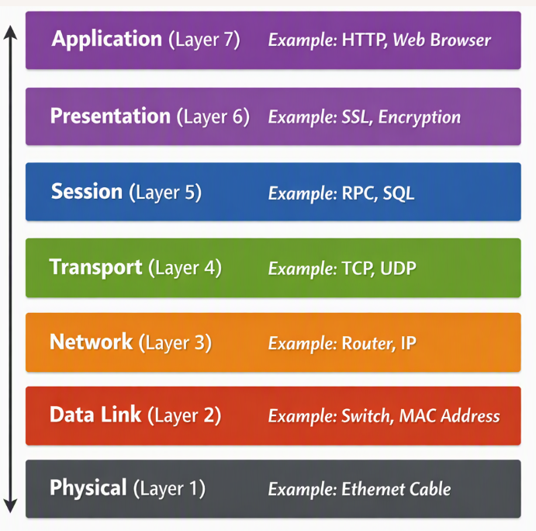
Suppose a student opens:
https://www.google.com
What happens?

Layer 7 – Application
Browser uses HTTPS.
Browser → HTTPS request

Layer 6 – Presentation
Data may be encrypted and represented in a suitable format.

Layer 5 – Session
Communication session is maintained.

Layer 4 – Transport
TCP manages reliable communication.
TCP
Port 443

Layer 3 – Network
IP addresses are used.
Source IP → Destination IP
Routers forward the packet.

Layer 2 – Data Link
The packet is placed inside a frame and MAC addresses are used on the local network.

Layer 1 – Physical
The data is converted into signals and transmitted through:
- Ethernet cable
- Wi-Fi
- Fiber

2.
Match the following networking scenarios to the correct OSI layer: a) Encrypting data before sending, b) Routing packets across networks, c) Converting data to electrical signals, d) Opening a web page in your browser, e) Detecting and correcting errors in frames.<br><br><em><strong>Hint:</strong> Write your answers as 'Scenario: Layer Name (Layer Number)'.</em>
a) Encrypting data before sending: Encrypting data before sending: Presentation Layer (Layer 6)
b) Routing packets across networks: Routing packets across networks: Network Layer (Layer 3)
c) Converting data to electrical signals: Converting data to electrical signals: Physical Layer (Layer 1)
d) Opening a web page in your browser: Opening a web page in your browser: Application Layer (Layer 7)
e) Detecting and correcting errors in frames: Detecting and correcting errors in frames: Data Link Layer (Layer 2)

3.
Pick any app you use daily (like WhatsApp, Instagram, or Zomato) and describe how at least three different OSI layers are involved when you send or receive data in that app.
Application Layer (Layer 7): You type a text message or select a photo in the WhatsApp interface and tap Send. The app uses higher-level protocols to convert your user action into network data.
Presentation Layer (Layer 6): WhatsApp applies end-to-end encryption to protect your message before it leaves your device. It also compresses high-resolution photos into optimized formats (e.g., JPEG).
Transport Layer (Layer 4): The encrypted payload is broken into smaller segments. WhatsApp uses TCP to ensure reliable deliverability and segment reordering so no chat message is lost or corrupted in transit.

4.
Given this scenario: You are unable to access a website, but you can successfully ping its IP address. Identify which OSI layer(s) might be causing the problem and explain your reasoning.
Problem: You can ping a website’s IP address but cannot access it in your browser.
- Likely Layers Involved:
  - Application Layer (Layer 7): The web service (HTTP/HTTPS) may be down, even though the server responds to ICMP ping.
  - Presentation Layer (Layer 6): SSL/TLS handshake issues could block the browser from loading the page.
  - Session Layer (Layer 5): Session establishment may fail, preventing the browser from opening a connection.
Reasoning:
- Ping uses ICMP at Layer 3 (Network), which proves the server is reachable.
- Failure to load the webpage points to higher layers (5–7) where protocols like HTTP/HTTPS operate.

